

# Machine Learning Project Initial Prototype

**Subject:**

Introduction to Machine Learning

**Topic:**

Extracting specific frames from a video

**Submitted to:**

Dr. Muhammad Nauman

**Submitted by:**

Junaid Ahmad p12-6095

Muhammad Awais Afzal p12-6029

Syed Nauyan Rashid p12-6345

BS (Computer Science)

**Department of computer science**

**FAST – National University of Computer & Emerging Sciences**

**Peshawar campus**

**Extracting Images Using Matlab**

1. Load video in matlab variable. (the video file must be in the current directory)

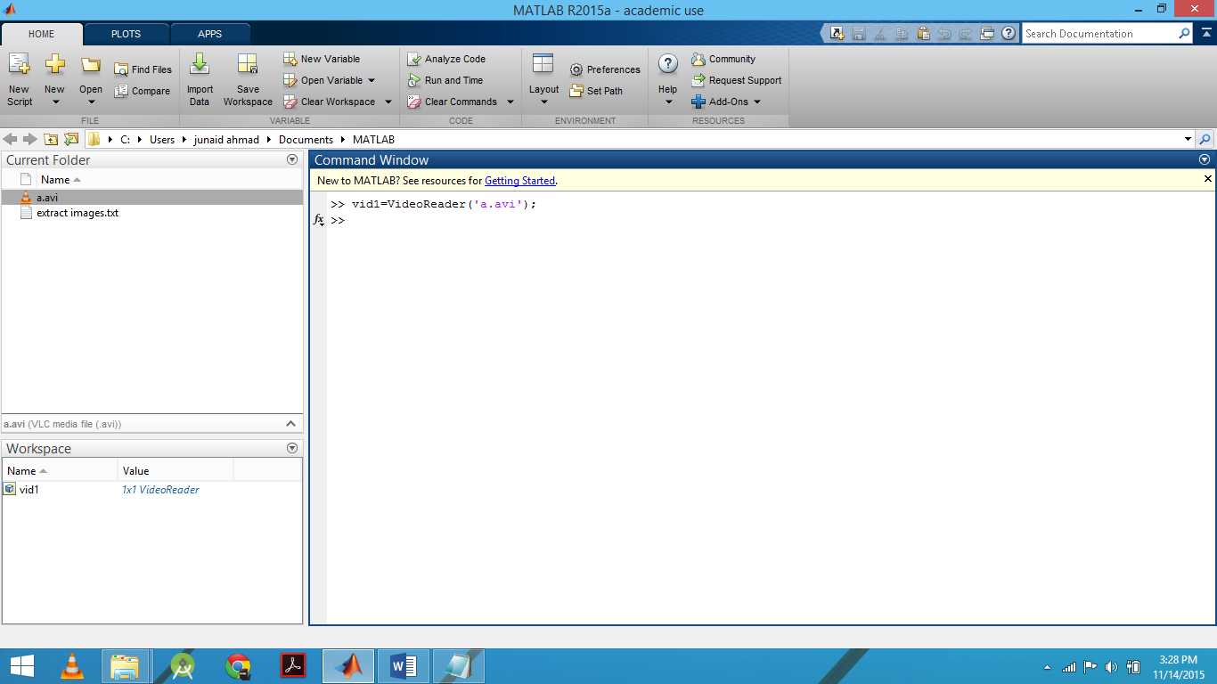

1. Specify number of frames

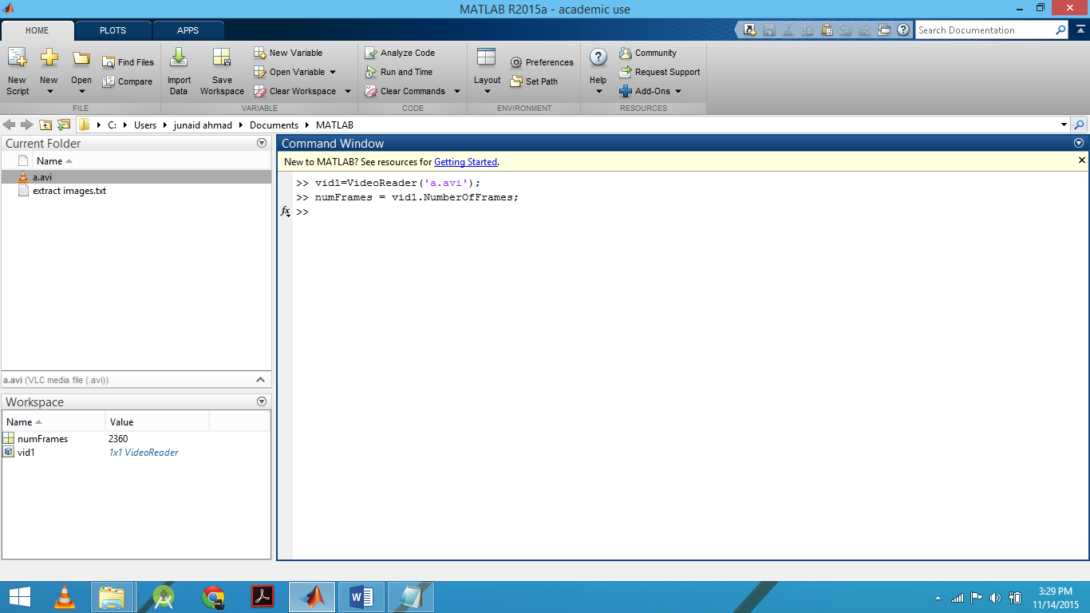

1. Extract frames

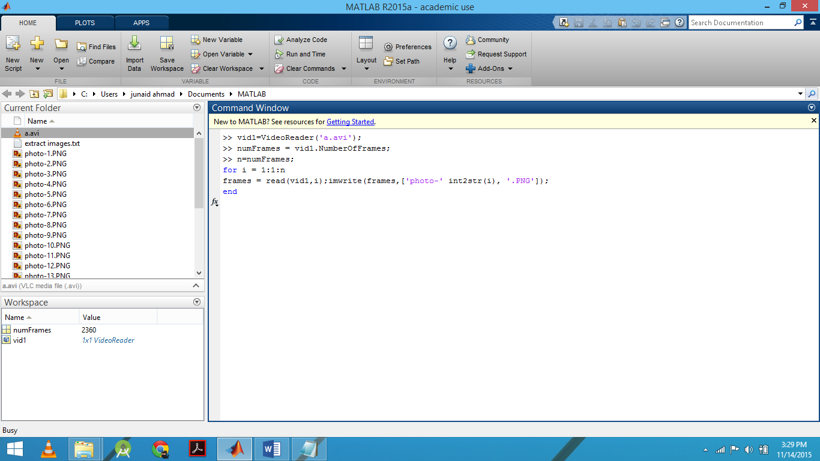

1. Sample images



**Errors:**

Following errors were occurred when running the matlab code:

1. matlab videoreader unable to determine the codec required

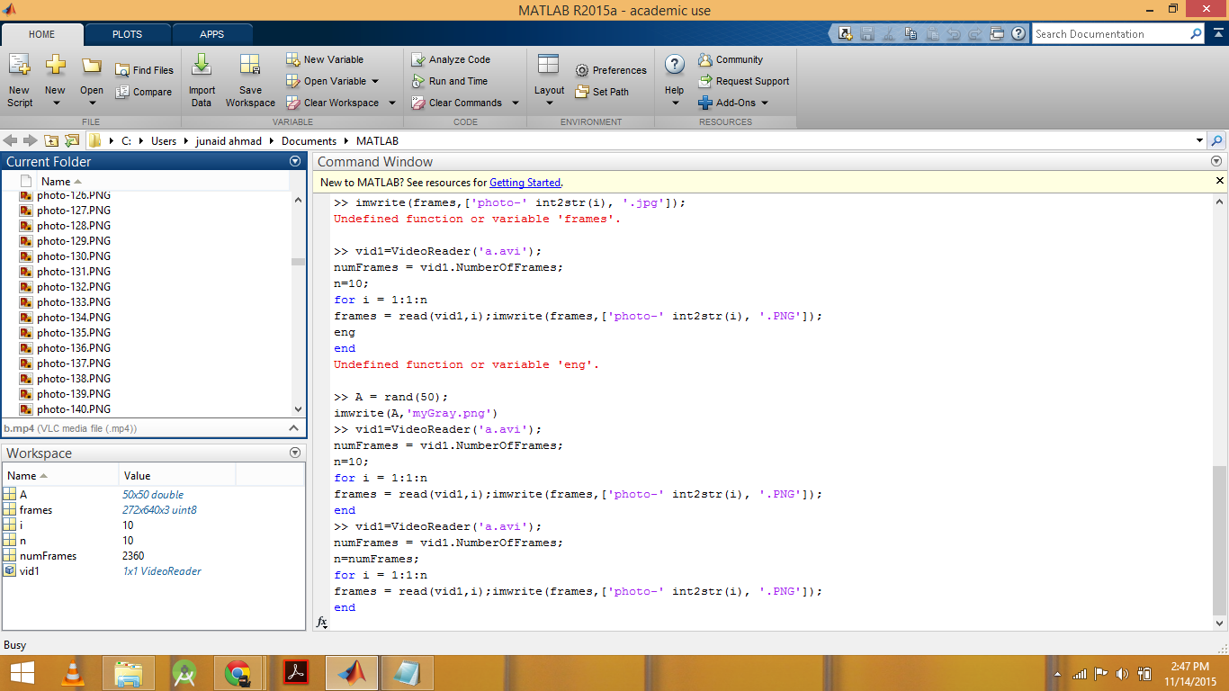

**Solution:**

* 1. Identified the codec required i-e Xvid
  2. Downloaded the Xvid from [**http://en.softonic.com/s/free-download-windows-8.1-xvid**](http://en.softonic.com/s/free-download-windows-8.1-xvid)
  3. Intstalled Xvid codec.

**Contribution of each team member:**

Junaid ahmad---- identified method for extracting images by using matlab and searching for relevant code.

Muhammad awais----- made changes according to our requirement and run the code.

Syed Nauyan Rashid---- Found solutions for the errors encountered.